ORA725 Lab 7

Submitted by: Naderi Vadakkeperatta, Anaswara

Due by Tuesday, December 12th by 4pm

You will create 2 tables firstly, then add / modify /remove some columns and finally add / modify / remove some constraints in this lab.

1. Create table SALESREP from table EMPLOYEES by using following columns (do NOT create this table from scratch), but only for people in department 80.

SALESREP
Column Type
RepId NUMBER(6)
FName VARCHAR2(20)
LName VARCHAR2(25)
Phone# VARCHAR2(20) → ALL these columns’ data types match ones
Salary NUMBER(8,2) in table EMPLOYEES
Commission NUMBER(2,2)
→ You will have exactly 3 rows here.

Solution:

CREATE TABLE salesrep AS
SELECT employee_id "REP_ID", first_name "FNAME",
last_name "LNAME", Phone_number "PHONE#",
salary, commission_pct "COMMISSION"
FROM employees
WHERE department_id = 80
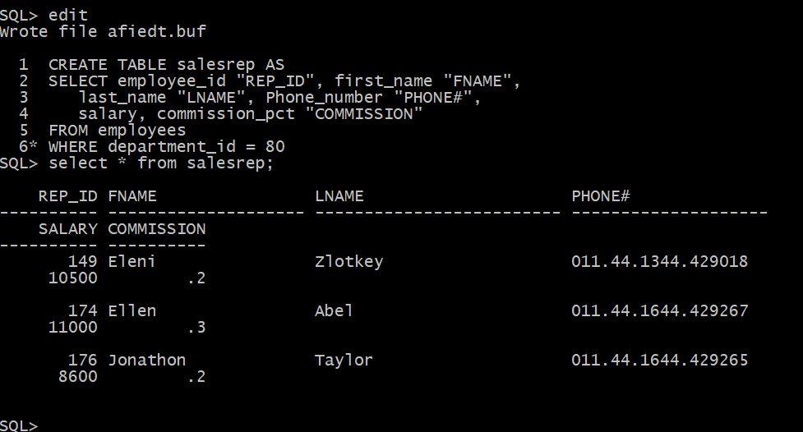

2. Create table GOODCUST from table CUST by using following columns (do NOT create this table from scratch), but only if their rating is A or B.

GOODCUST
Column Type
CustId NUMBER(6)
Name VARCHAR2(30)
Location VARCHAR2(20) → ALL these columns’ data types match ones
RepId NUMBER(7) in table CUST
→ You will have exactly 4 rows here.

Note: If you have NOT created table CUST yet, then follow the script from my Practice in Chap10 and run it (just omit column Comments and also omit the FK constraint – if you did not create tables DEPART and EMPL). Also add 7 rows to this table like shown:

CUST# | CUSTNAME | CITY | RAT | SALESREP#
501 | ABC LTD. | Montreal | C | 201
502 | Black Giant | Ottawa | B | 202
503 | Mother Goose | London | B | 202
701 | BLUE SKY LTD | Vancouver | B | 102
702 | MIKE and SAM inc. | Kingston | A | 107
703 | RED PLANET | Mississauga | C | 107
717 | BLUE SKY LTD | Regina | D | 102
7 rows selected.
Solution :
CREATE TABLE goodcust As
SELECT Cust# "CustId", Custname "Name",
City "Location", SalesRep# "RepId"
FROM cust
WHERE Rating IN('A', 'B')

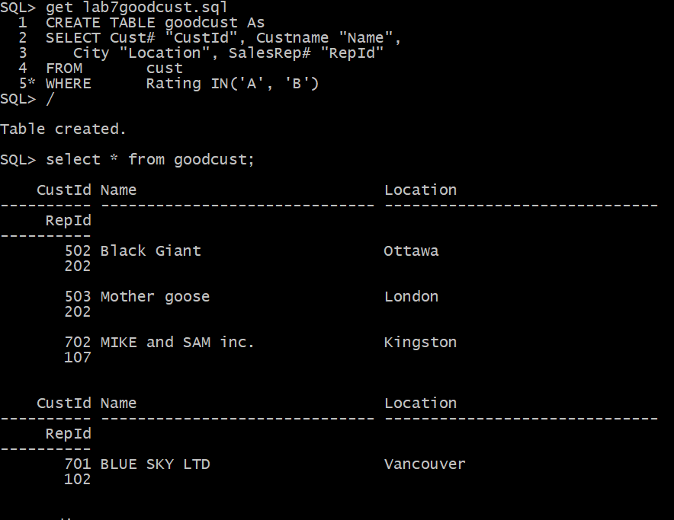
3. Now add new column to table SALESREP called JobCode that will be of variable character type with maximum length of 12. VARCHAR(12)

ALTER TABLE salesrep
ADD JobCode VARCHAR(12)



4. Declare column Salary in table SALESREP as mandatory one and column Location in table GOODCUST as optional one.

Solution:

ALTER TABLE salesrep
MODIFY salary NUMBER(8,2) NOT NULL

ALTER TABLE goodcust
MODIFY “Location” NULL

5. Then decrease the length of column Name in table GOODCUST to the lowest possible value by performing a “smart” SELECT statement first (and NOT by counting characters visually)

Solution:

SELECT max(length("Name"))
FROM goodcust
WHERE LENGTH("Name") > any(SELECT LENGTH("Name") FROM goodcust)

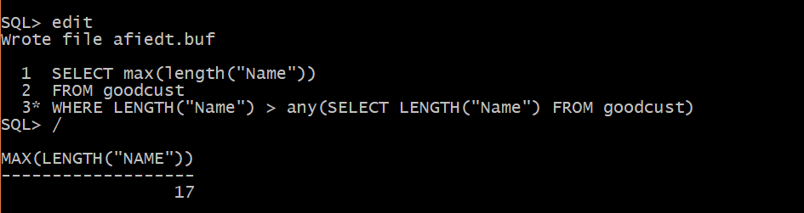

ALTER TABLE goodcust
MODIFY “Name” VARCHAR2(17)

6. Now get rid of the column JobCode in table SALESREP in a way that will not affect daily performance.
Solution:

ALTER TABLE salesrep
SET UNUSED COLUMN jobcode ;

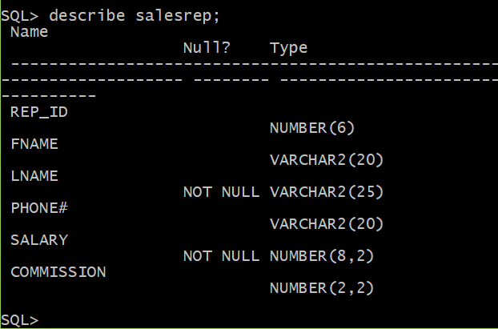

7. Declare PK constraints in both new tables → RepId and CustId

Solution:

ALTER TABLE salesrep
ADD CONSTRAINT salesrep_repid_pk PRIMARY KEY(Rep_Id)

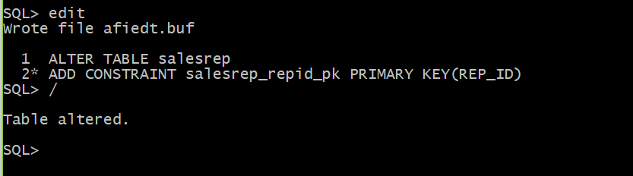

ALTER TABLE goodcust
ADD CONSTRAINT goodcust_CustId PRIMARY KEY("CustId")

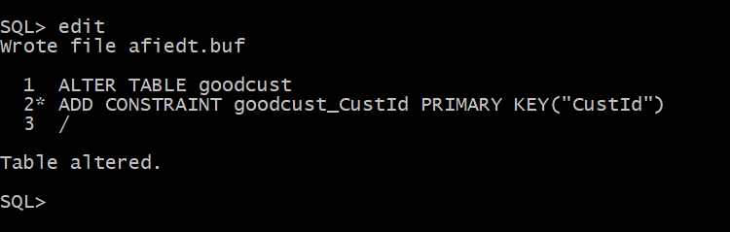

8. Declare UK constraints in both new tables → Phone# and Name

Solution:

ALTER TABLE salesrep
ADD CONSTRAINT salesrep_phone#_uk UNIQUE(Phone#)

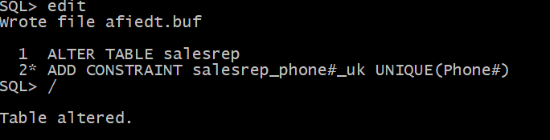

ALTER TABLE goodcust
ADD CONSTRAINT goodcust_Name_uk UNIQUE("Name")
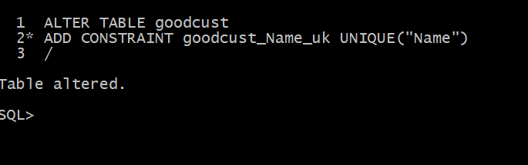

9. Restrict amount of Salary column to be in the range [6000, 12000] and Commission to be not more than 50%.
Solution:

ALTER TABLE salesrep
ADD CONSTRAINT salesrep_commission_ck CHECK( commision <= .5)

ALTER TABLE salesrep
ADD CONSTRAINT salesrep_salary_ck CHECK(salary BETWEEN 6000 AND 12000)

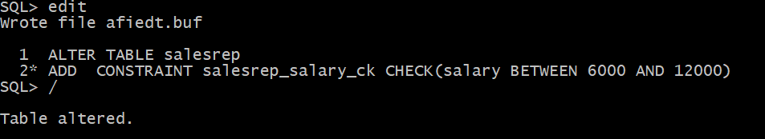
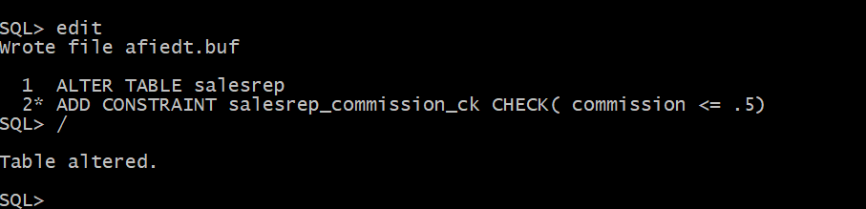

10. Ensure that only valid RepId numbers from table SALESREP may be entered in the table GOODCUST. Why this statement has failed?

Solution:

ALTER TABLE goodcust
ADD CONSTRAINT goodcust_repid_fk FOREIGN KEY("RepId")
REFERENCES salesrep ("REP_ID")
*
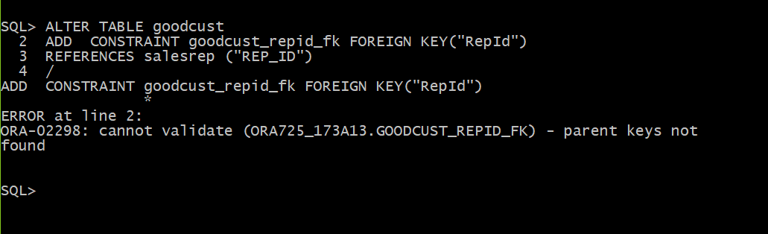

Here, there is no parent key values corresponding to the RepID value in good cust table.

FOREIGN KEY constraint on column RepId that allows only values from the set of values for repid column in the parent table Salesrep to be entered (and rep id values does not exist as salesrep there )

11. Firstly write down the values for RepId column in table GOODCUST and then make all these values blank. Now redo the question 10. Was it successful?
Solution:

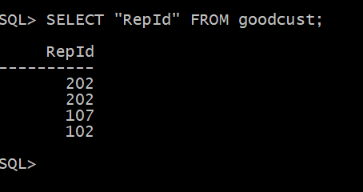

UPDATE goodcust SET "RepId" = null;
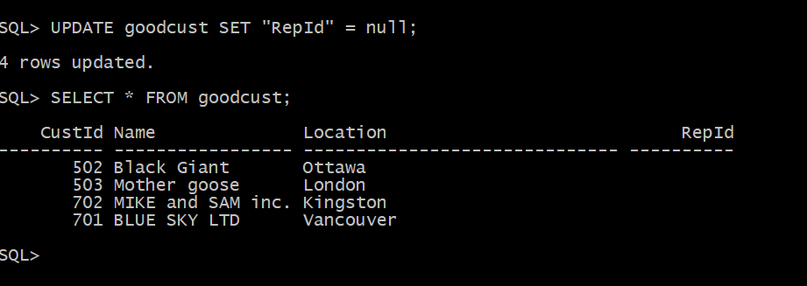

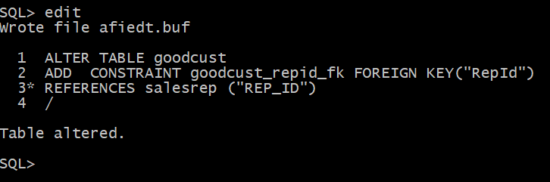

12. Disable this FK constraint now and enter old values for RepId in table GOODCUST and save them. Then try to enable your FK constraint. What happened?

Solution:

ALTER TABLE goodcust DISABLE CONSTRAINT GOODCUST_REPID_FK;

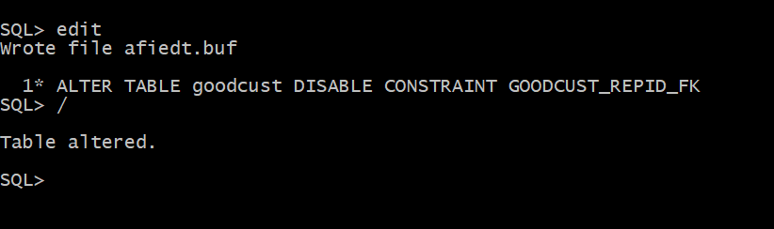

UPDATE GOODCUST
SET "RepId" = &RepId
where "CustId" = &CustId

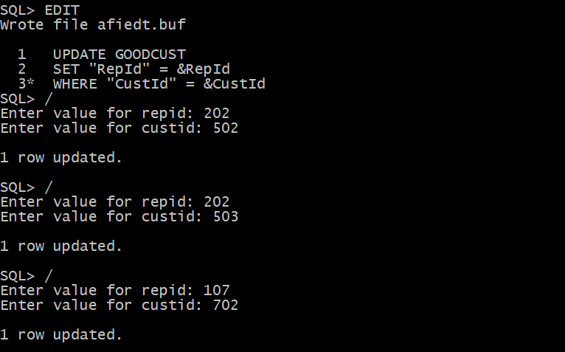
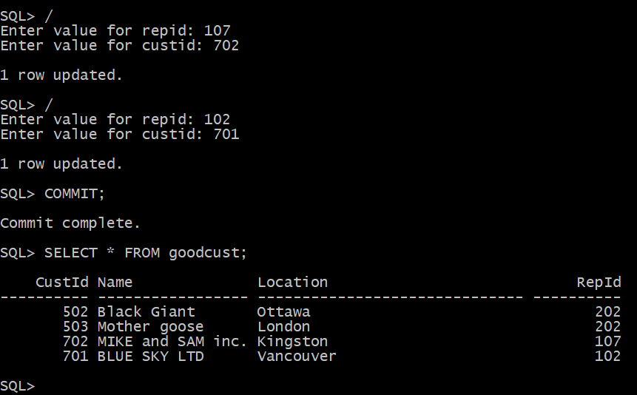

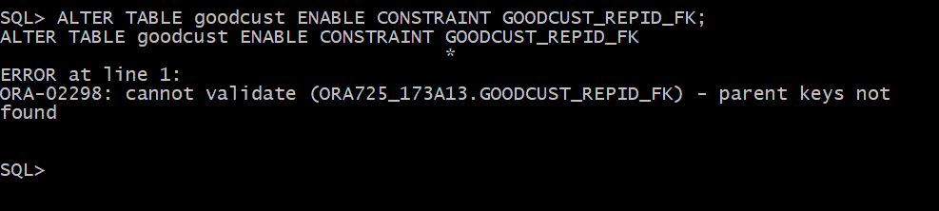

FOREIGN KEY constraint on column RepId that allows only values from the set of values for repid column in the parent table Salesrep to be entered (and rep id values in the goodcust table does not exist as salesrep there )

13. Get rid of this FK constraint. Then modify your CK constraint from question 9 to allow Salary amounts from 5000 to 15000.

Solution:

ALTER TABLE goodcust DROP CONSTRAINT GOODCUST_REPID_FK

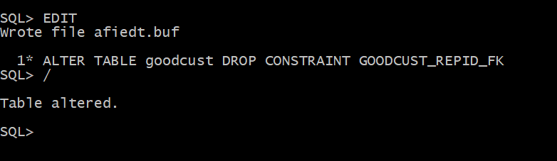

ALTER TABLE salesrep
DROP CONSTRAINT SALESREP_SALARY_CK

ALTER TABLE salerep
ADD CONSTRAINT salesrep_salary_ck CHECK(SALARY BETWEEN 5000 AND 15000)

14. Describe both new tables SALESREP and GOODCUST and then show all constraints
for these two tables by running the following query:

Solution:

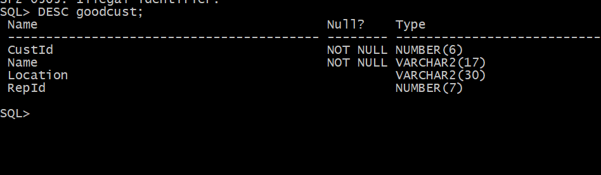

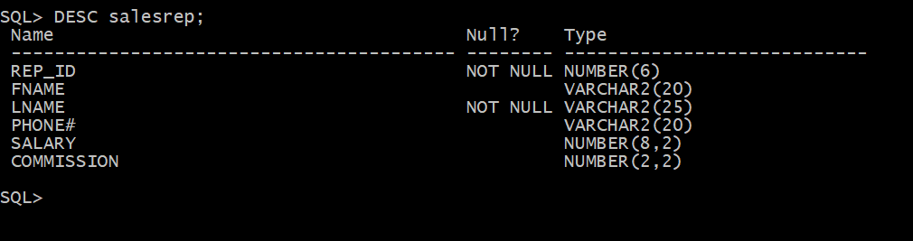

SELECT constraint_name, constraint_type, search_condition, table_name
FROM user_constraints WHERE table_name IN (‘SALESREP’,’GOODCUST’)
ORDER BY 4 , 2

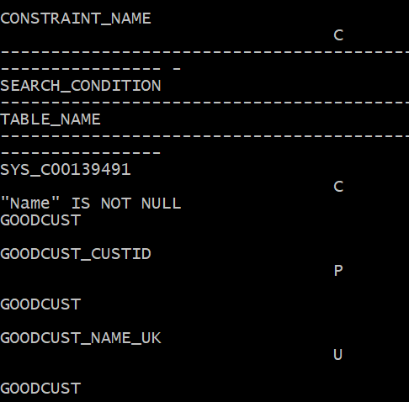
w
